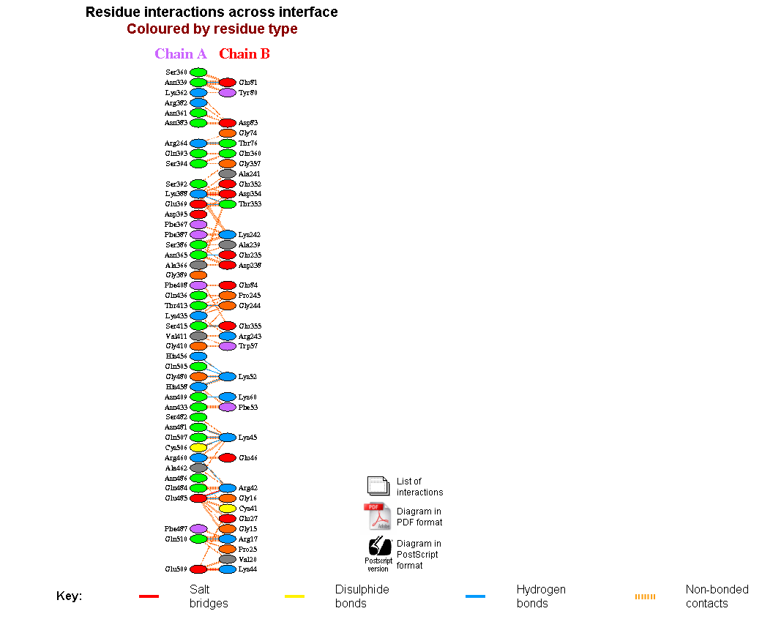



**Fig (a). Protein-protein interaction between vaccine and Tlr4**

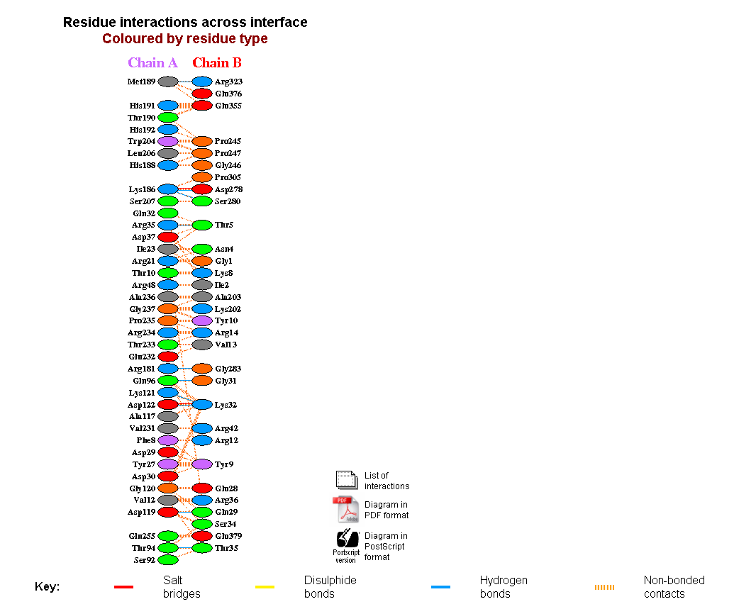



**Fig (b). Protein-protein interaction between vaccine and MHC1**

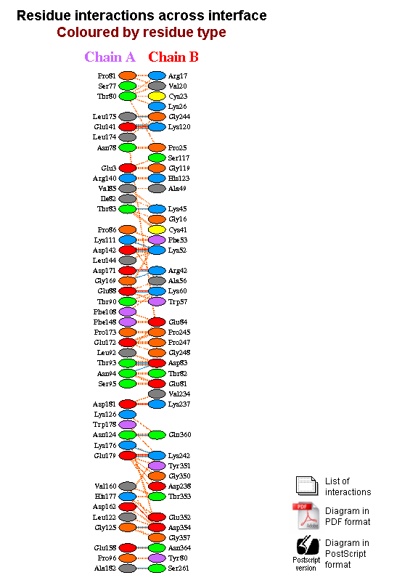



**Fig (c). Protein-protein interaction between vaccine and MHC2**